1.

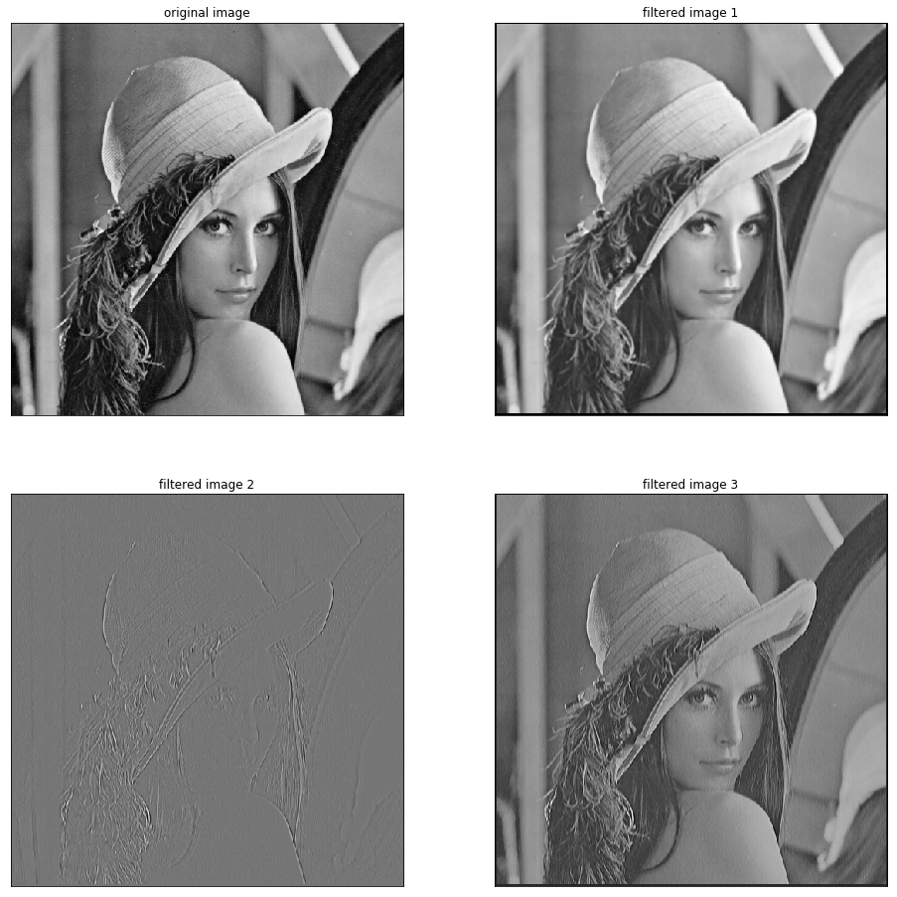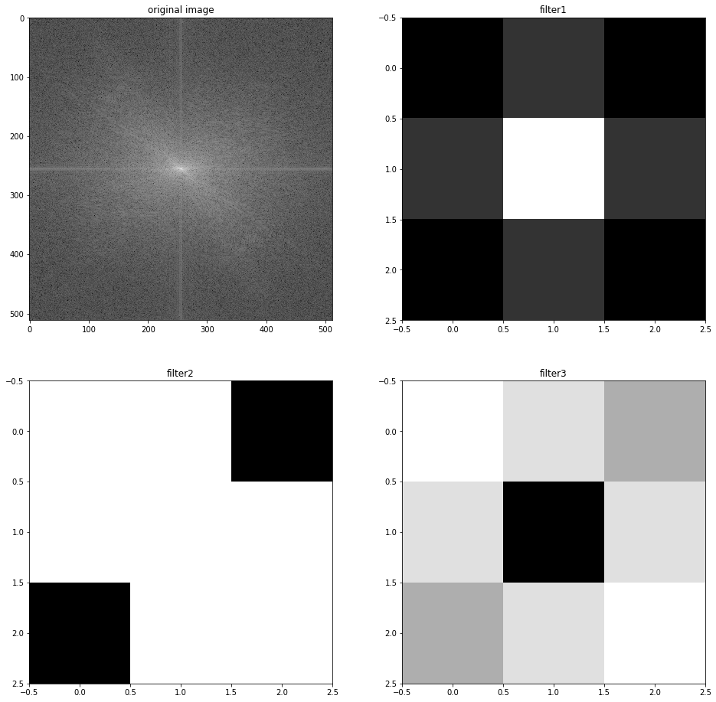

Filter 1 smooths the original image. Filter 2 stresses the edges of the image and suppresses the other parts. Filter 3 is a HPF, witch stresses on edges and also causes some noise on the image.

2.

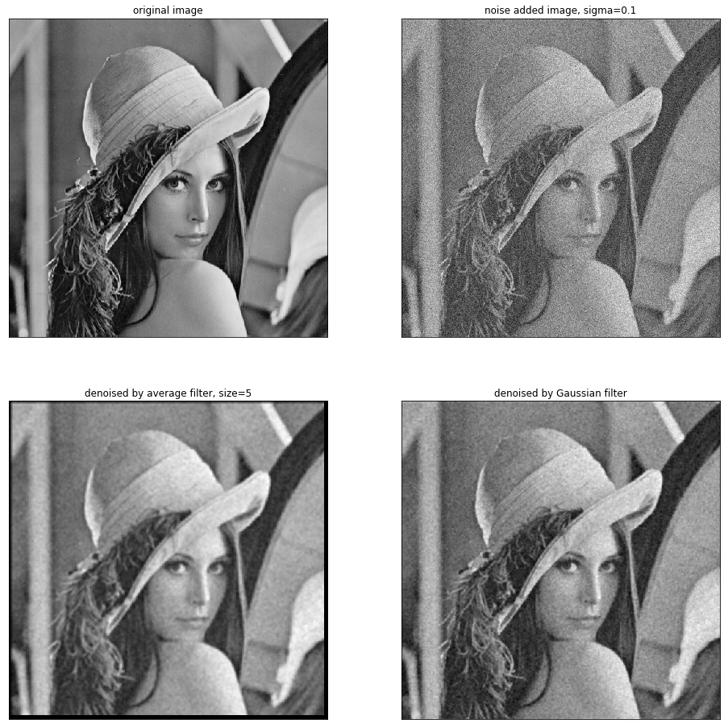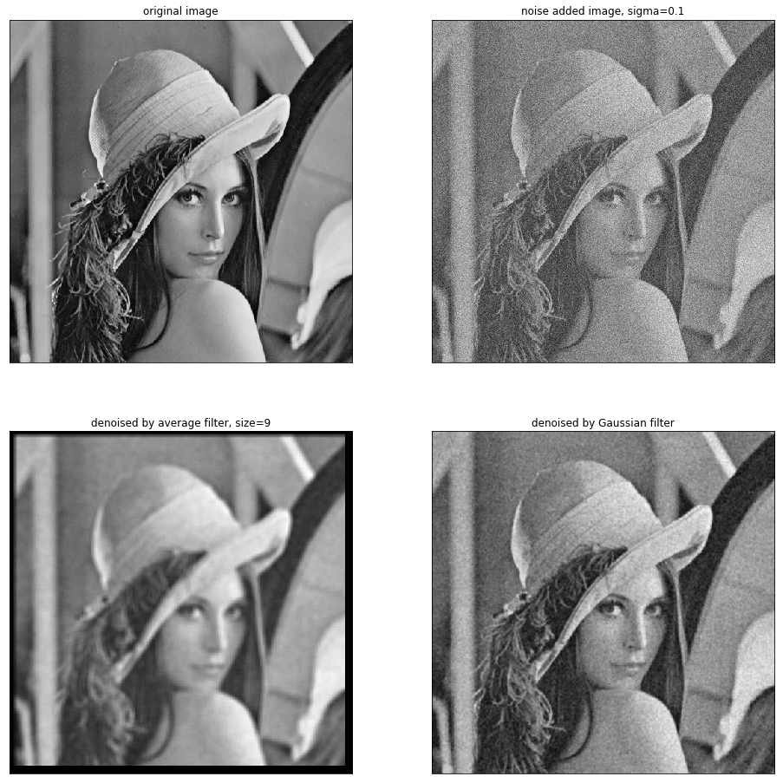

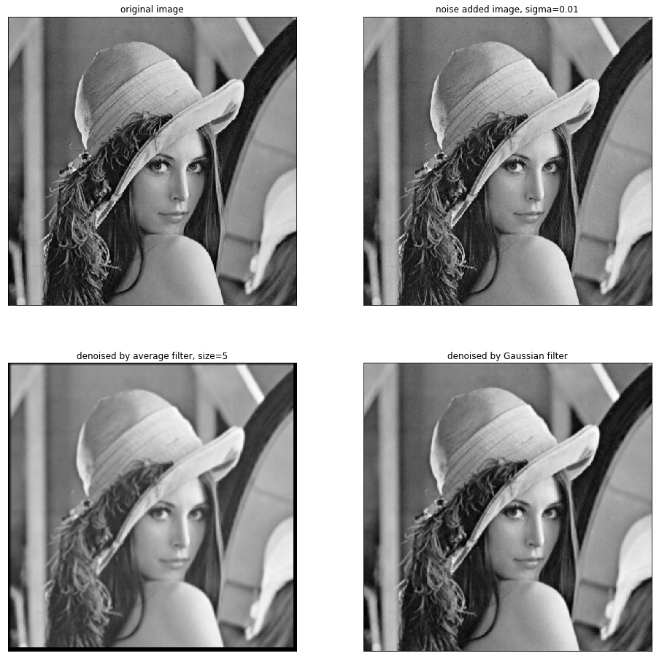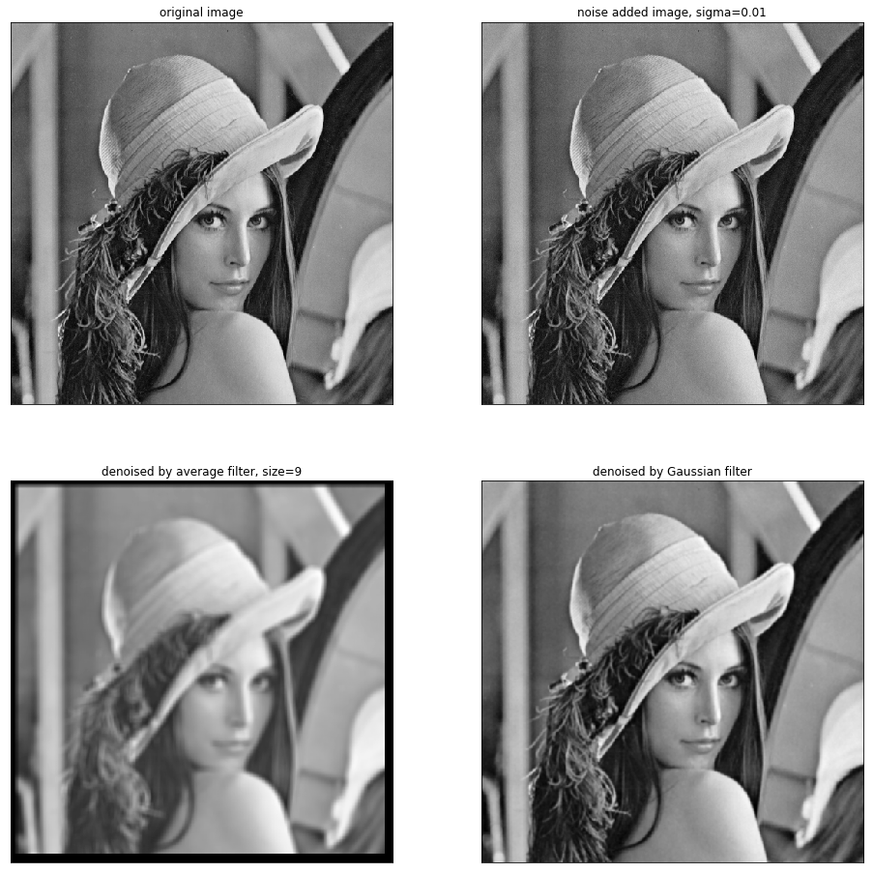

Compare: when noise level=0.1, size 9 filter removes the noise better; while noise level=0.01, size 5 filter is large enough to remove the noise without blurring too much on the image.

The efficiency of Gaussian filter depends on the sigma we choose, and by changing the sigma value we can always get good performance on Gaussian noise removal.